Sigma 30mm F1.4 DC DN Contemporary for Sony E-mount lens review
Published Sep 12, 2016 | Samuel Spencer
Share

Buy on Amazon.com From $288.00
Previous |  |  | 1 Introduction |  | 2 Next
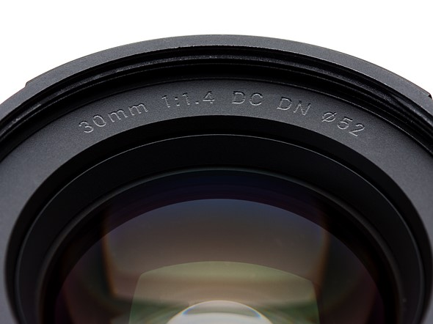
The Sigma 30mm F1.4 DN DC Contemporary was announced in February 2016, and sits atop Sigma's line of DN mirrorless lenses, with a two-stop advantage over their previous 30mm F2.8 offering. It's currently the only APS-C F1.4 autofocus lens currently available for the Sony E-mount and has an MSRP of $339.00.
With F1.4 and a 45mm equivalent field of view, this lens on paper appears to be a good choice for a 'walkaround' normal prime lens. The bright aperture will satisfy low light shooters and bokeh fanatics, and the near 50mm field of view puts it right inside the versatile 'normal' lens range. While it won't replace a dedicated macro lens with its magnification ratio of 1:7, it still is able to focus down to a working distance of 30cm (less than a foot).
The relatively low price, especially for an E-mount lens, means it's also accessible to beginners and enthusiasts alike, making it sound like an ideal prime lens that may never leave the front of the camera once it's mounted.
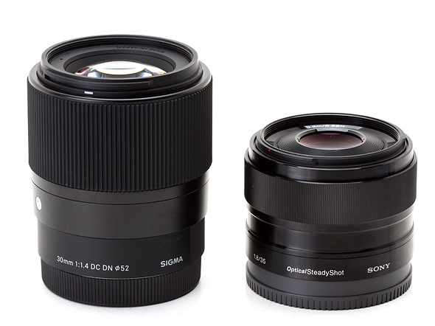
Within the E-mount system this lens has one natural competitor: the Sony 35mm F1.8 OSS. Let's look at how the two stack up on paper:
 | Sony E 35mm F1.8 OSS | Sigma 30mm F1.4 DC DN | C
MSRP | $448 | $339
Image Stabilization | Yes | No
Max Aperture | F1.8 | F1.4
Minimum Aperture | F22 | F16
Aperture Ring | No | No
Diaphragm Blades | 7 | 9
Number of elements | 8 | 9
Number of groups | 6 | 7
Special elements/coatings | 2 aspherical elements | 1 aspherical and 1 double-sided aspherical
Minimum Focus | 0.30 m (11.81″) | 0.30 m (11.81″)
Maximum Magnification | 0.15x | 0.14x
Motor Type | Stepper motor | Stepper motor
Full Time Manual | No | No
Weight | 155 g (0.34 lb) | 265 g (0.58 lb)
Dimensions (DxL) | 63 x 45 mm (2.5 x 1.8 in.) | 65 x 73mm (2.6 x 2.9 in.)
Sealing | None | None
Filter Thread | 49mm | 52mm
In terms of just spec we see a couple of major differences. First, while the Sony is 2/3 of a stop slower than the Sigma, it does include optical image stabilization. That alone gives it a better chance at being the preferred lens for video, although when shooting 4K the slightly wider FOV of the Sigma might fare better on any body that gives an additional crop.
In stills terms, though, there's little real-world difference between the Sigma's 45mm equivalent view and the 52.5mm equivalent of the Sony. The difference between them doesn't suddenly open one up to a type of photography that couldn't be achieved with the other.
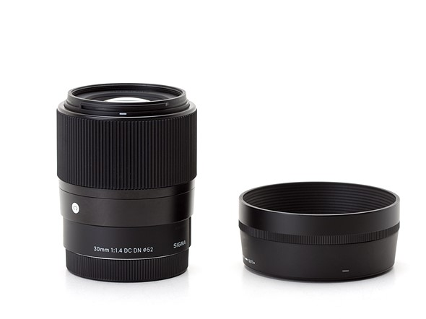
Build quality between the Sigma and the Sony is fairly similar. They both use a machined metal chassis with plastic internals. Compared to older Sigma DN lenses, the 30mm F1.4 doesn't let its focus elements rattle about when unmounted, which is a very welcome change. The focus ring is also an improvement, and a step above the Sony. The rubber grip turns smoothly and easily with minimal effort, making the Sony feel a bit stiff. The only downfall in terms of build is the Sigma's lens hood, which doesn't seem to confidently click in to place, and is made of rather fragile feeling plastic.
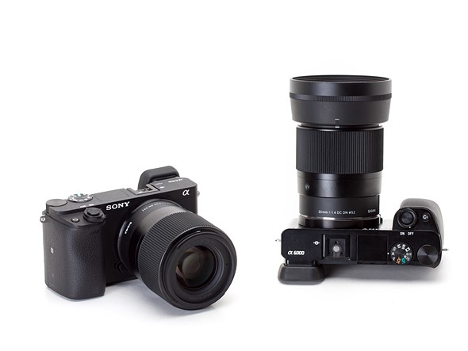
The long barrel of the Sigma, and even longer overall dimensions do make it quite large in comparison to APS-C Sony Alpha cameras, but the weight isn't entirely off-balance. While heavier and much bigger, it is less expensive and brighter than the Sony 35 F1.8. The question is, does the extra weight and lack of OSS keep it from topping the Sony as the ideal 'normal' for APS-C E-mount shooters?

