Canon 24mm f/1.4 L II USM lens
Published Sep 17, 2008 | dpreview staff

Pre-Photokina 2008: Along with the EOS 5D Mark II, Canon has announced its latest addition to the EF lens family, the 24mm f/1.4 L II USM fast aperture wide angle prime. The new lens has undergone a complete redesign and now features 13 elements in 10 groups, including two high-precision glass-molded aspheric elements and two UD glass elements, plus a floating focus mechanism to maintain performance across the entire distance range. It also features Canon’s brand-new ‘Sub Wavelength structure Coating’ technology to minimize flare and ghosting, and is sealed against dust and inclement weather.
Jump to:
- Press Release
- Specifications
- Additional images
- Sub Wavelength structure Coating
Press Release:

Canon enhances EF series with new
EF 24mm f/1.4L II USM fast aperture wide-angle prime lens
Amstelveen, The Netherlands, 17 September, 2008: Canon today strengthens its line-up of EF-series lenses with the introduction of a new fast aperture prime lens: the EF 24mm f/1.4L II USM. Replacing the EF 24mm f/1.4L USM, the EF 24mm f/1.4L II USM has been completely redesigned to provide an exacting partner lens to Canon’s new EOS digital SLRs, the EOS 50D and EOS 5D Mark II.
The EF 24mm f/1.4L II USM offers:
- Fast f/1.4 aperture
- Aspherical and UD lens elements for correction of chromatic aberration
- Sub Wavelength structure Coating (SWC) to dramatically reduce ghosting and flare
- Circular aperture for pleasing bokeh
- USM for full-time manual focus
- Lead-free glass (RoHS compliance)
- Lens hood and pouch supplied
Superior image performance
Featuring a 13-element, 10-group lens, the EF 24mm f/1.4L II USM is designed to achieve the highest standards of image quality. Two high-precision GMo aspheric lenses are employed to correct various forms of aberration such as curvature of field and distortion, with a floating mechanism ensuring crisp corner-to-corner detail throughout the focal range. In addition, two UD lenses reduce the chromatic aberration common in wide-angle lenses.
A fast, ultra-large maximum aperture of f/1.4 delivers excellent low-light performance, with the circular aperture offering the potential for creative out-of-focus highlights. A focal length of 24mm and a USM focus motor providing full-time manual focus also make the EF 24mm f/1.4L II USM ideal for situations where a wide-angle, high-performance lens is required.
Advanced lens coating
Reflections off a digital camera’s image sensor can compromise images with ghosting and flare. To help reduce this, the inside of EF 24mm f/1.4L II USM’s front element is treated with Canon’s new Sub Wavelength structure Coating. Developed specifically to work with Canon optics, this anti-reflective coating helps reduce flare and ghosting - for consistently crisp, undistorted images.
Robust build quality
The EF 24mm f/1.4L II USM is designed to withstand the rigours of even the most testing shooting environment – with Canon’s advanced weather and dust sealing making it the perfect choice for photojournalists and landscape photographers.

EF 24mm f/1.4L II USM lens specifications
Maximum format size | 35mm full frame
Focal length | 24mm
Diagonal Angle of view (FF) | 84º
Maximum aperture | F1.4
Minimum aperture | F22
Lens Construction | • 13 elements/10 groups  • 2 high refraction glass elements  • 2 UD Lens Elements
Number of diaphragm blades | 8
Minimum focus | 0.25m (9.9 in)
Maximum magnification | 0.17x
Focus | • Manual  • Auto-Focus
Focus method | Rear focus with floating mechanism
AF motor type | • Ring-type ultrasonic  • Full-time manual focus
Image stabilization | None
Filter thread | • 77mm  • Does not rotate on focus
Supplied accessories | • Front and rear caps  • EW-83K hood  • LP1319 Lens Pouch
Weight | 650g (22.9 oz)
Dimensions | 93.5mm diameter x 86.9mm length  (3.7 x 3.4 in)
Lens Mount | Canon EF only
Other | • Weather sealed  • Provides distance information for E-TTL II flash metering

Additional images
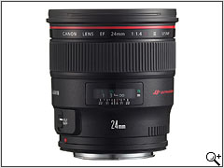 | 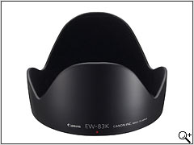

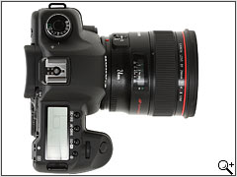

Sub Wavelength structure Coating
The 24mm F1.4 L USM II sees the debut of Canon's new 'Sub Wavelength structure Coating' (SWC) technology. Considered by Canon to be considerably more effective then their existing 'Super Spectra Coating', the new coating is applied to the inside surface of the front lens element, and is designed to minimize flare and ghosting caused by secondary reflections between the sensor surface and the lens elements, which can lead to significant image degradation in digital SLRs.
The new biomimetic coating is inspired by features found within the eyes of moths, and uses a nano-scale structure to reduce dramatically the amount of internally-reflected light in lenses that contain large curve-radius elements. It is therefore particularly effective with fast wideangles such as the new 24mm F1.4L II USM.

How it works

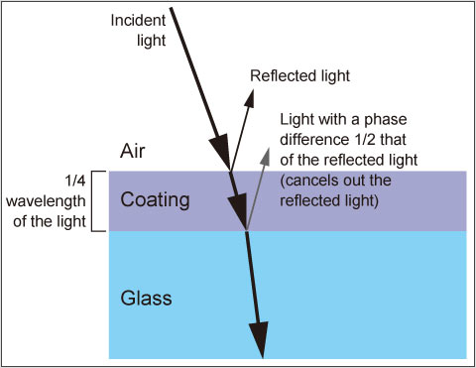
Conventional anti-reflective coatings work by creating two surfaces off which light can reflect: one at the boundary between the coating and the air, and a second at the boundary between the coating and the glass. The thickness of the coating ensures the distance between these two surfaces is one quarter of the wavelength of light. Consequently, any light reflecting off the second (coating/glass) surface will be half a wavelength out of phase with the light that reflected off the first (air/coating) surface, by the time it has bounced back and will cancel it out.
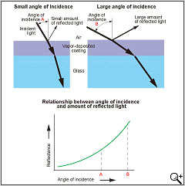 | Unfortunately, this process only works well when the light strikes the surfaces relatively straight-on (having a small angle of incidence). As the angle at which the light strikes the coating becomes less direct, more light is reflected.
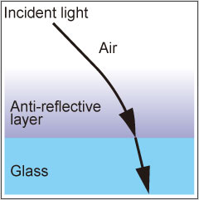 | Canon's new coating works by varying the density of the coating, depending on the distance from the glass surface.
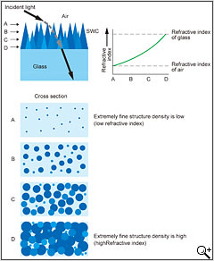 | The coating's ordered, nano-scale structure means that light encountering it is bent as it travels into the increasingly dense coating (and encounters an increasingly high refractive index).  The result is that it always reaches the coating/glass boundary at a relatively direct angle, reducing the reflection, particularly at the edges of lenses or, in this instance, on highly curved lens surfaces.
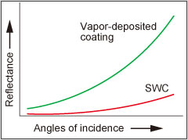 | The new SWC coating dramatically reduces light reflected off the lens surfaces compared to Canon's conventional vapor-deposited Super-Spectra Coating especially at high angles of incidence.

